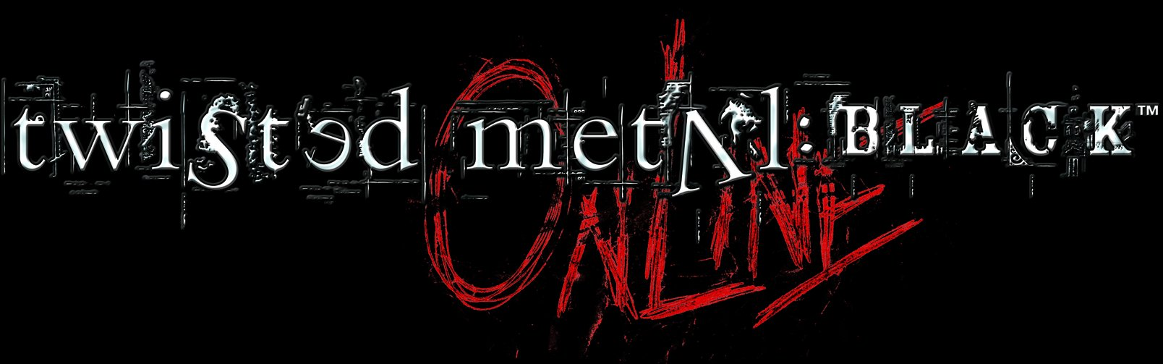

GAME OVERVIEW:

Deep within the mind and buried in the soul, lies madness in us all. A descent into darkness reveals the insanity where an unsettling silence looms on the brink of total anarchy. And there’s only one way out…Twisted Metal:Black OnlineTM.

Designed and developed by the original Twisted MetalTM team, Incog Inc Entertainment, the team often credited with creating and perfecting the car combat genre. Twisted Metal:Black OnlineTM gives players the opportunity to battle against each other online in the ultimate test of their car combat skills.

Capitalising on the technological prowess of the PlayStation®2, Twisted Metal: Black OnlineTM delivers rich textures, superior graphics, and outstanding special effects, bringing the team’s shocking and imaginative vision to life. Twisted Metal: Black OnlineTM challenges the mind with skill while engaging the heart with terror. Although destruction is at the game’s core, mental and physical agility are required for the most creative kills. Take to the wheel of incredible jacked-up vehicles and command the most insane set of rigged-up weapons yet. Rip through foreboding battlegrounds and nightmarish landscapes in a wickedly dark world that is sure to bring out the madness in us all.

After a successful promotion in the US last year (2002), the eternally demented car combat Twisted MetalTM series, will be available to play online with other PlayStation®2 owners with Network Gaming access across Pan-European territories. Twisted Metal: Black OnlineTM is an ideal introduction to online gaming on a console as it offers immediatly accessible gameplay and instant gratification but this time against far more intelligent and challenging opposition.

Game synopsis:

Enter an online arena of frenzied car combat across twenty huge 3D battle zones with turbo-charged vehicles, awesome weaponry, grisly violence and macabre mayhem for those of us who know no fear!

Characters and Story:

Twisted Metal: Black OnlineTM does not include a storyline. The game is car combat in it’s purest form. However the gameplay does not differ from the original Twisted Metal: BlackTM version. The story was about a mysterious man named Calypso that breaks out a group of deranged and cursed individuals from an insane asylum so they can compete in his car combat tournament. All of the characters have a ghastly history as to why they're in the asylum and many of their horrific lives intertwine in some fashion or another. Basically, all the characters have gone through hell and have scores to settle.

For more information on SCEE titles, please visit our website
www.playstation.com

Developer: Incog Inc. Entertainment/SCEA Santa Monica Studios Genre: Car Combat/Driving and shoot’em up
No. of Players: 1-8 Platform: PlayStation®2
Peripherals: Network Adapter, Analog Controller (DUALSHOCK®2), Memory Card (8MB) (for PlayStation®2)
Release Date: Staggered rollout with Network Adaptor starting with UK in May 2003

Sony Computer Entertainment Europe Ltd.

Sony Computer Entertainment Europe, based in London, is responsible for the distribution, marketing and sales of PlayStation, PS one and PlayStation 2 hardware and software in 102 territories across Europe, the Middle East, Africa and Oceania. At the end of September 2002, over 36 million PlayStation units had been shipped across these PAL territories and over 92 million worldwide. Between its European debut on 24 November 2000 and 15 January 2003, over 16 million PlayStation2 units have been shipped across the PAL territories, over 50 million world-wide, making it one of the most successful computer entertainment products in history.

PlayStation and the PlayStation logo, PS one and PS2 are registered trademarks of Sony Computer Entertainment Inc. All other trademarks are the property of their respective owners.

More information about PlayStation products can be found at http://www.scee.com and http://www.playstation.com .

